Br. Puthenparampil Thommachan OFS
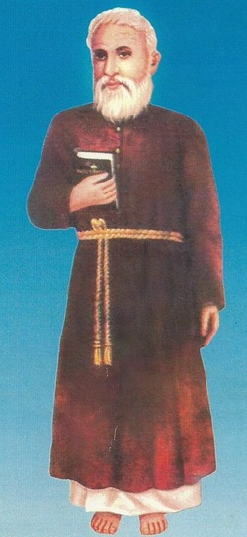
Thommechan was born on the 8th July 1836 and was baptized as Thomas. When Thommechan was about two years and a half old his father, Philippose died.His mother, Thresiamma then looked after him.
Proficiency in Tamil enabled Thommechan to read first hand several religious and devotional books in Tamil. Most of the books available then were in Tamil. Prominent among them was the Bible and lives of the Saints including that of St. Francis of Assisi.
He was prone to be prayerful contemplative, ascetical, withdrawn. He would concentrate on devotional exercises and prayers and seek solitude and meditation.
He got married to Annamma, daughter of Mathachan, Vadakkeveettil of Pulincunnu parish. She was just an ordinary, normal catholic girl, not particularly given to be over-enthusiastic about the pious practices of her bridegroom. But Thommechan's sense of values and piety made him a loyal and dutiful husband. So he gave in to all that was expected of him as a husband and father.
In the normal course of his family life a son and two daughters were born to him.
In 1865, when Thommechan was about 28 years old, he called together a number of his like minded companions, all bent on consecrating their lives in the service of God, without renouncing their temporal responsibilities. He had heard of the distinguishing Franciscan Cord as a symbol of restraint - something that would tie up your wandering or bursting thoughts - something that would remind you that you are tied to, bound to, a mooring point, a focus of spirituality. He found the thin strands of a coconut fiber robe, with its sharp, strong and piercing bristles as a suitable inner girdle to be worn close to the body. This physical gesture was supplemented by some self imposed regulations conducive to a virtuous living and external works of charity like helping the poor, conversion of the depressed classes, more systematic observance of the Sabbath etc. One day during the spiritual reading they were making at their Sunday meetings, this prayer group came across the story of the foundation of the Third Order by St. Francis of Assisi, for married people living in the world. Soon Thommechan procured a copy of the rules of the Franciscan Third Order. Thommechan saw that St. Francis and his brother friars actively engaged themselves in missionary activities and felt that, that was the immediate call open to his fraternity. There were around him plenty of Harijans who were living in subhuman conditions, denied of all rights of equality with their brethrn in the matter of education, worship, use of public highways etc. Untouchability and unapproachability were among the vices prevalent among them.The fraternity put up a shed in the common lands there and organised the teaching of catechism in groups formed according to age. This association of Thommechan with the low caste people raised protests from the well placed families.
This fraternity was distinguished by the rope they tied around their waist. They were even addressed as "the fraternity of the roped". Braving such ridicule, Thommechan worked on enrolling more members in different parishes. He travelled all over Kerala preaching the Franciscan message in the churches. From 1868 onwards Thommechan was engaged in this mission and he succeeded tremendously in spreading the Franciscan message throughout Kerala.
On the 26th Dec. 1868, the feast of St. Stephen, he was vested. Following the common practice of the religious, of chosing an alternate name, as a mark of their shedding their old personality and accepting a new one, Thommechan chose 'Louis' as a sur-name. From then on, Thommechan was known in the religious fraternities as Thommen Louis. St Louis is the patron saint of the Franciscan Tertiary brothers.
Thommechan died on 1st November 1908.
Puthenparambil Thommachan, popularly known as Kerala Assisi, was declared as ‘Servant of God’ on Friday 29th June 2012..

